Introduction
This section describes how to enter an event.
It is important that you follow the instructions in Appendix 1 at the bottom of this document if this is the first time you have tried to login or enter an event.

Members
Club Members should never use the NON-MEMBER REGISTRATION option. Doing so will record you as a NON-MEMBER. This will result in you loosing preference in the draw and request you pay the non-members entry fee.

Non-Members
If you are a non-member but think the club may have your details on record then please email info@tyneteestweedfta.com and I will check the database and advise you how to proceed
If you are a non-member then please follow the ‘Register’ instructions.

Enter Event (Figure 1)
- From the menu bar select the breed you are interested in (Spaniel in the following examples) and then click Information
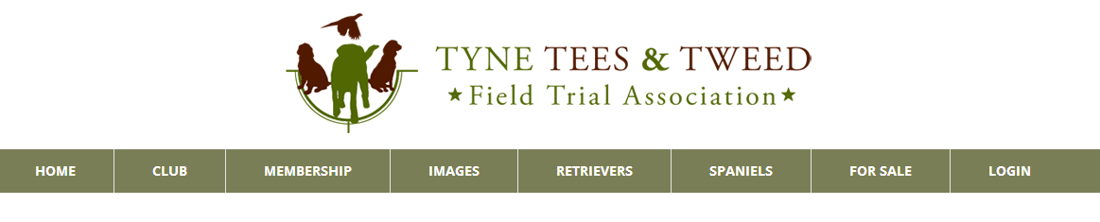
Figure 1
- This will take you to the Spaniel Information page (Figure 2). The current stakes will be listed with option to enter online. Click ‘Enter On-line’ to start the entry process.
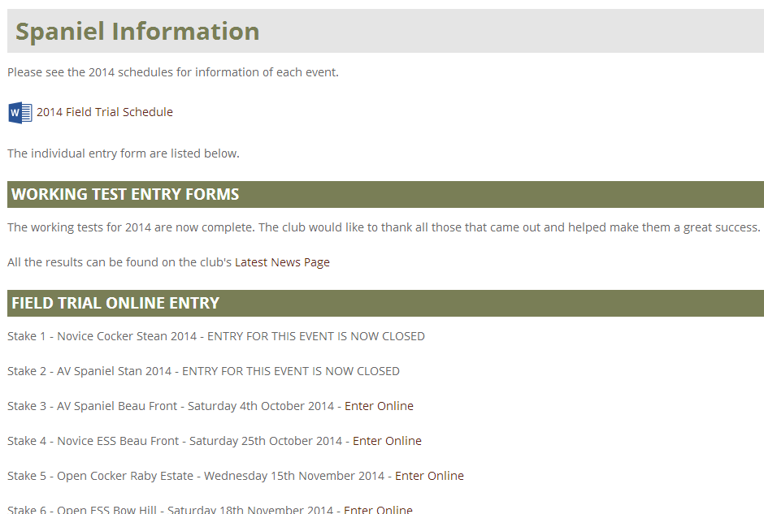
Figure 2

- You will be presented with a summary of the event and stake information (Figure 3). Having read the information click ‘Login and Enter Event’
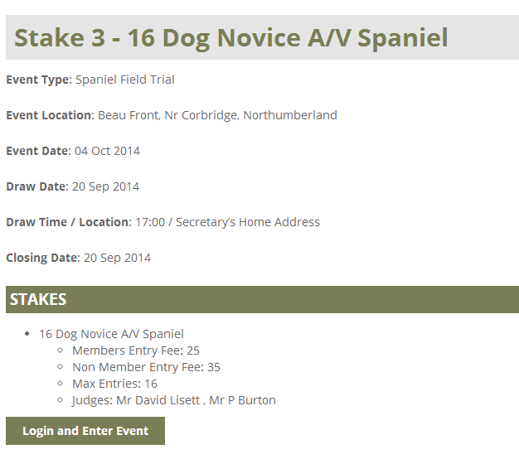
Figure 3
- Enter your Email address and Password and click ‘Login’ (Figure 4)
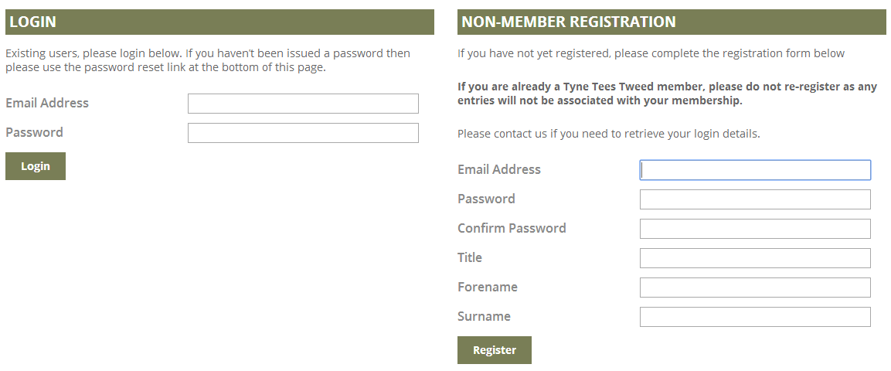
Figure 4

Event Entry Form (Figure 5)
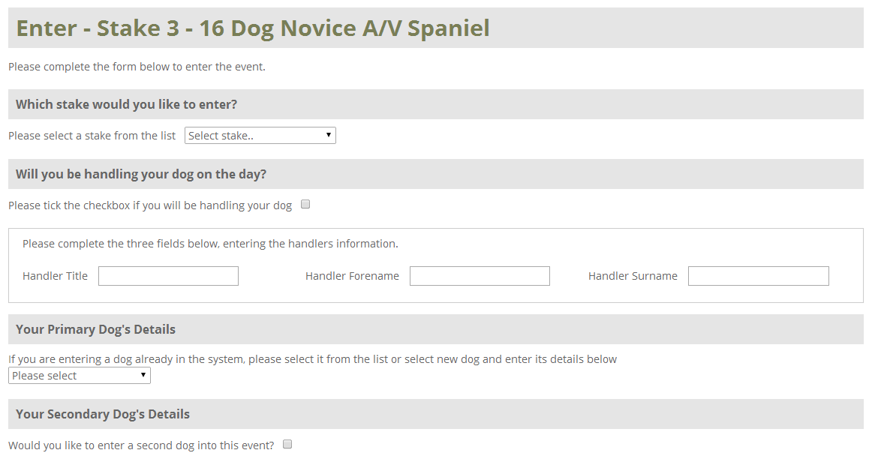
Figure 5
Complete all the relevant sections of the entry form.
- Which stake would you like to enter: Select the stake you wish to enter? Most field trials will only have one stake, working tests will have multiple stakes
- Will you be handling the dog on the day?: Put a tick in the box if you will be handling the dog. If not then complete the three fields with the handlers details
- Your Primary Dog’s Details: Click the dropdown box and select ‘Add new dog’ this will present the fields to enter the required information (Figure 6). If you have previously entered an event then your dog may be listed for you to select.
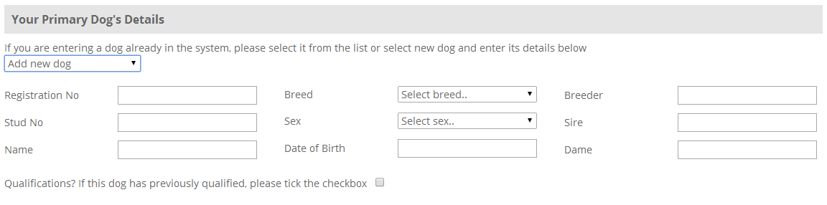
Figure 6
- Registration Number: Enter the dog’s registration number if it has not been awarded a stud book number.
- Stud No: Enter the dog’s stud book number if it has been awarded one.
- Name: Enter the dog’s name only. Do not prefix with FTCH. You indicate your dog is a field trial champion within the qualification section.
- Breed: Select the dogs breed.
- Sex: Select the dog’s sex.
- Date of Birth: Use the date picker to select the dog’s date of birth.
- Breeder: Enter the breeder’s name.
- Sire: Enter the name of the sire. You can prefix with FTCH
- Dam: Enter the name of the dam. You can prefix with FTCH
- Qualification?: If you are entering an Open stake and your dog has a qualification put a tick in this box.
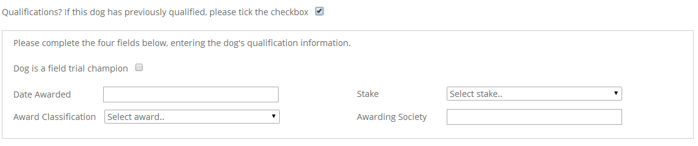
Figure 7
- Dog is a field trial champion: Tick this box if your dog is a Field Trial Champion.
- Date Awarded: Use the date picker to select the date of the qualifying award.
- Award Classification: Select the qualifying award received.
- Stake: Select the type of stake that the qualification was awarded at.
- Awarding Society: Enter the name of the society that held the stake.

- You can choose to enter a second dog by answering the next question and then repeating the instructions above.
- Read the declaration and confirm that you agree to this by ticking the box ‘I/ We hereby agree to the stated terms of entry’ (Figure 8).
Please note that payment for on-line entries will be by cheque, on the day of the event.
Check the details you have entered and then submit your entry (Figure 8).
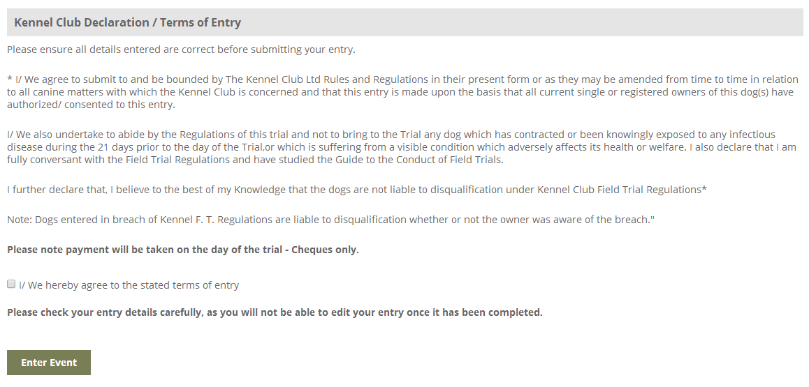
Figure 8

- Your entry is now complete (Figure 9).
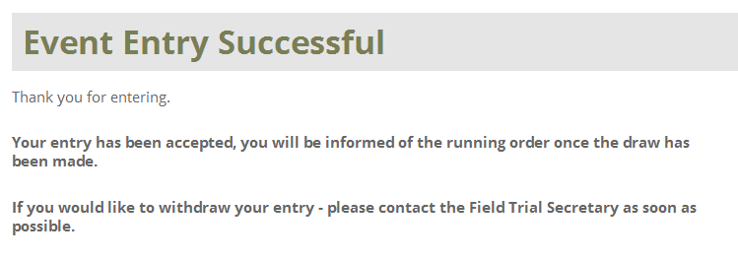
Figure 9
- You will receive a confirmation email (Figure 10)
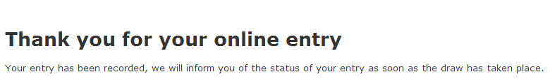
Figure 10

Appendix 1

When you visit the website you will now see the option to ‘Login’ on the menu bar. Before using this, please follow the information below carefully.

If you are unsure of which email account the club has recorded for you, then please email info@tyneteestweedfta.com and I will advise you.

If you have changed your email and not advised the club, then please email info@tyneteestweedfta.com and I will update your record and let you know when you can follow the information below.

It’s very important that all members follow the instructions; logging in to the website will be required for a number of features including on-line entry to field trials and working tests.

Before you login you MUST reset your password. Click the following link to go to the Password Reset page, http://www.tyneteestweedfta.com/reset-password.

Enter your email address and click ‘Reset Password’. You will be sent an email that contains a link to the page where you can enter your chosen password.

Having reset you password you can now use the ‘Login’ menu to login. You will be taken to the Client Details page. This will allow you to administer your own details and breeds of interest. You will also see the status of your membership and your membership number.

Note: Club Members should never use the NON-MEMBER REGISTRATION option. Doing so will record you as a NON-MEMBER and will affect some of the features coming soon.

