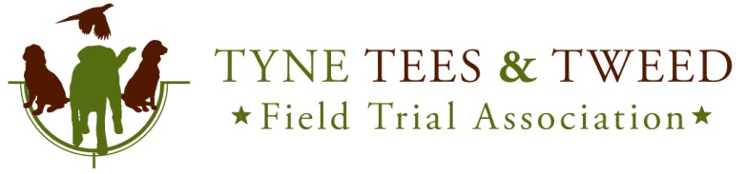
Kennel Club I.D. 181

Spaniel Trials 2015
Held under Kennel Club Limited Rules and Regulations ‘J’

Re-Schedule of Stake 7

Due to unforeseen circumstances Stake 7, 16 Dog Novice A/V Trial to be held on the 5th December at Pockstones Estate has been cancelled.

The stake has been re-scheduled as below. All entries to the cancelled trial and any entry made on an entry form for the cancelled trial will be transferred, there is no need to re-enter.

- 16 Dog Novice A/V 2015 to be held on 28 Nov 2015 at Weardale Estates, Co Durham by kind invitation of the guns.
Judges: Mr. G. E. Wilson (A 2935), Mr. C. Oakley (NP)
Closing Date: 14th November
Draw Date: 16th November, 20:00
Draw Location: The secretary’s home address. All welcome, please advise if attending.
Meet: 9:00am Details with the draw. Please send S.A.E or Email in block capital for result of the draw.

Entry fees and all other terms and conditions remain the same as the original schedule.

For further information or if you have entered and the new date is not convenient please contact the field trial secretary.

Steve Charlton,
Fell House,
Allendale, Hexham,
Northumberland,
NE47 9AG
Home 01434 683730 Mobile 07951776854
E Mail spaniel.sec@tyneteestweedfta.com or s.j.charlton1@btinternet.com

