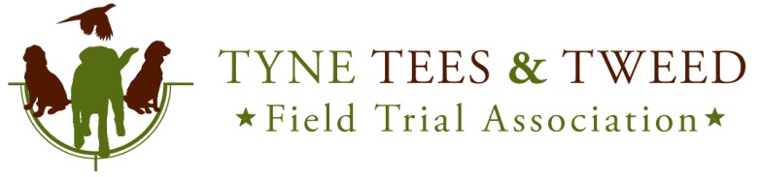
Kennel Club I.D. 181

Spaniel Working Tests 2023
Held under Kennel Club Limited Rules and Regulations ‘J’

Test 1 – A/V Spaniel Novice and Open to be held on Sunday 21st May 2023 at Elton Moor Farm by kind permission of Mr Jonathan Marsh
Judges: Mr Steve Winspear (A), Mr Dan Own (NP)
Closing Date: 14th May 2023
Draw Date:
Meet: 9:00am at Elton Moor Farm, Stockton-on-Tees, TS21 1BQ - WhatThreeWords - ///credit.spun.fund

The test will only go ahead if sufficient entries are received.

The Club/Hosts accept no responsibility for injury, loss or damage to persons or property however occasioned.

Entries: Entries MUST be by the WEBSITE or POST only. No entries will be accepted by Email.

All successful WEBSITE entries will be confirmed by email. If you receive no email, then your entry has not been accepted. Entries can be checked on the events page you have just used to enter. Check the 'Entries' tab.

All payments will be taken on the morning of the test. Any cheques must be made payable to ‘Tyne Tees & Tweed FTA’. The Working Test Secretary reserves the right to refuse a run if payment is not made.

Entry Fees:

Novice Entry Fee | Members £10  Non-Members £15 | NOVICE. Confined to dogs which have not gained a place or certificate of merit at a field trial, been placed first, second or third in an Open GWT or first in a Novice GWT held in accordance with Kennel Club Rules and Field Trial Regulations.
Open Entry Fee | Members £10  Non-Members £15 | OPEN. Open to all dogs of a specified breed or breeds, although preference may be given to dogs which have gained a place or certificate of merit at a field trial, been placed first, second or third in an open GWT, or won a Novice GWT

Postal Entries:

David Jennings,
19 Douai Drive,
Consett,
Co Durham,
DH8 7DN

Mobile 07702201815 – Please keep trying as a voice mail my not get picked up in good time.
E Mail info@tyneteestweedfta.com

DOGS IN CARS ON HOT DAYS
Your dog is vulnerable and AT RISK if left in a vehicle in high temperatures and even on days considered as slightly warm. Please take care of your dog.
If your dog is found to be at risk forcible entry to your vehicle may be necessary without liability for any damage caused.

WELFARE of DOGS
An exhibitor (or competitor) whose dog is entered at a Kennel Club licensed event should take all reasonable steps to ensure the needs of their dog(s) are met, and should not knowingly put their dogs’ health and welfare at risk by any action, default, omission or otherwise. A breach of this Regulation may be referred to the General Committee for disciplinary action under Kennel Club Rules and Regulations.

TRIAL ETIQUETTE
We should never fail to acknowledge the generosity of hosts which makes field trials possible. Clearly it is desirable that as many competitors as possible are present when the presentations are made at the conclusion of a field Trial: not least because that is the most obvious way of showing such appreciation. There may be occasions, however, when a competitor feels it important or necessary to leave the ground before the end of the trial. If that happens, she or he must be sure to show due courtesy by informing the Chief Steward before leaving. Good manners, which cost nothing, should be at the heart of everything we do: especially where our hosts are concerned.

